# Part 3 Talking about a leader you admire -> e.g. Jeffrey in DP project

## Words

#### Underling (subordinate, inferiority V.S. superior, superiority [suː,pɪərɪ'ɒrɪtɪ; sjuː-] 上级，优越感)

* 1.N-COUNT You refer to someone as an **underling** when they are inferior in rank or status to someone else and take orders from them. You use this word to show that you do not respect someone. 走卒(表不满). Subordinate, inferiority [ɪn,fɪərɪ'ɒrɪtɪ]
* E.g. This can be avoided by explaining to the messenger that you are saving the feelings of the malodorous underling.  [跟读](javascript:;)

但这种情况是可以避免的，方法是向那位代言人解释，你是在照顾那个有体味下属的感受。

[www.hjenglish.com](http://www.hjenglish.com/subject/bec/page/69756/?page=2)

* 2.

If a manager's failed office romance forces him or her to focus more heavily on the work, his increasing demands on, for example, a pregnant underling could give her the grounds for a lawsuit.  [跟读](javascript:;)

如果经理因为自己办公室恋情的失败而强迫他或她能做更多的工作，要求也越来越多。 例如，怀孕的下属就可以以此为由提起诉讼。

[article.yeeyan.org](http://article.yeeyan.org/view/163378/136990)

* 3.

It would make him feel like a child or an underling.  [跟读](javascript:;)

那让他感到自己像个孩子或妻子的部下

吞并 Swallow up V.S. 合并merge V.S. 收购acquire

#### swallow up ***(swallowing,swallowed,swallows):* buy out** 或 **take over** 的另一种表达是 **swallow up**。该表达强调执行收购的公司规模比被收购的公司**大很多**。

* 1.PHRASAL VERB If one thing **is swallowed up** by another, it becomes part of the first thing and no longer has a separate identity of its own. 吞并 e.g. During the 1980s monster publishing houses started to **swallow up** smaller companies. 20世纪80年代期间，巨型的出版公司开始**吞并**较小的公司。
* 2.PHRASAL VERB If something **swallows up** money or resources, it uses them entirely while giving very little in return. 用光 (金钱或资源) ， 但是只有非常少的回报 e.g. A seven-day TV ad campaign could swallow up the best part of $100,000.7天的电视广告宣传能把$100000基本用

Executive ladder 行政阶梯， 管理层 (the managerial[mænə'dʒiːrɪəl] rank 管理层) e.g. *He talked to people much further down the* ***executive ladder*** *than him.* 他和级别低他很多的人交谈 e.g. I've been trying to climb the executive ladder in my company for years.

Considerate V.S. thoughtful

Considerable, considerably: large or relatively large in number or amount or extent or degree相当大的

* 设定一个先例, 开创性，开创一个先例set a precedent = establish a new rule or standard that is followed by **considerable** people, set a **precedent of** doing e.g. Addressing this problem would also set a precedent for future dealings on patents with India, she added.  [跟读](javascript:;)

她补充说，解决这一问题还会为将来在印度处理知识产权问题提供先例. E.g “We hope we can set a precedent and help strengthen the protection of consumer rights in China,” said Mr Jiang. “我们希望，我们能够设定一个先例，帮助加强中国的消费者权益保护，”蒋苏华表

|  |  |  |  |  |  |
| --- | --- | --- | --- | --- | --- |
| 如果一位企业领导人干了一件开创性的大事，或者树立了未来的新标准，那你就可以使用表达 **set a precedent**： | | | | | |
|  |  | | | |  |
|  | *He* ***set a precedent***先例 *of talking to every employee in the company disregarding the level or rank.* | | | | 他开创了与公司所有员工交谈的先例。 |
|  |  | | | |  |
|  |  | | | |  |
| * 相对表示等级的 **rank** 一词，**position** 更为礼貌。 * **Underling** 是指级别更低的工人，意义偏于贬义。你有时也会听到有人使用 **subordinate**, inferiority一词，但是很少出现。注意这些句子是如何清楚表明谁是老板，而且不会过多强调职位和级别的。 * **Associate** 是用于同事之间表示尊敬的称呼 | | | |
|  | |  |  |
|  | |  |  |

* *He made time to talk to everyone, no matter what their* ***position*** *was.* 他抽时间和每一位员工谈话，不管他们的职位是什么。
* *The director is always* ***respectful of*** *the people* ***who work for him****.*
* 这位主管总是尊敬为他办事的人。
* *She is well-liked and admired by her* ***underlings/subordinates/inferiority***
* 她深受手下员工的爱戴。
* *This is my* ***associate/colleague****, Brad. He'll help you with the details of the contract.*
* 这是我的同事 Brad。他将帮你确定合同的细节。

## Tapescript

I think to select one individual as a businessman **I most highly respect or admire**, actually is a pretty easy decision to me. Uh, I think that man would be Joey Yang, who is a senior project manager when I was working in Nokia Semense before it was swallowe**d u**p by Alka LangXun. Joey **set a precedent** that a lot of his underlings/subordinates/inferiority follow, in that he was pretty good about speaking with people who were **considerably** below his rank远远低于 on the **executive ladder**, aka the **managerial[mænə'dʒiːrɪəl] ranks**, including me. And he also **carried right down**自上而下的执行 into people who worked in the factory.

## 谈论公司的等级制度

* **Horizontal** 或 **flat** 公司没有严格分明的等级制度。管理层与非管理层员工，甚至定期与客户合作共事。A horizontal/flat company
* **Vertical** 或 **tall** 类型的公司通常等级分明，**CEO** 处于最上层，发号施令，传达至最底层。这种架构通常称为 **top-down(**自上而下的**)**。A vertical/tall company

*The CEO's order* **is carried (right) down** *through all levels of the company.*-首席执行官的命令**自上而下传达**至公司的每一个阶层。

Orders are **top-down** in a **vertical** company = Orders are **carried right down** through all levels in a **vertical** company.

垂直型公司具有自上而下的组织结构 Vertical companies have a **top-down** organization.

*Our company is organized* ***vertically****, and it's quite difficult to* **climb the executive ladder (aka, the managerial ranks**管理层**).-**我们的公司采用垂直型架构，要升到管理层相当困难。

***Horizontal*** *management has people of all positions working together.*-水平化管理让所有职位不同的人合作共事。

公司内部的最高管理职位有时被称为 **C-level**，这些职位的首字母都是 **C, chief**，其中包括 **CEO**、**COO**、**CFO** 和 **CTO**。

***The CEO*** *will address in the* ***board of directors*** *next week.*-首席执行官下周将在**董事会**上发言。

在谈论他人的工作级别时，我们可以谈及他们职责方面的信息。

* *As HR manager, she is* ***in charge of*** *all hiring.*-身为人力资源经理，她负责所有的招聘事宜。
* *The CTO is* ***responsible for*** *15 engineers.*-那位首席技术官负责 15 位工程师。
* *He's* ***head of*** *the accounting department.*-他是财会部门的主管。
* *All department directors* ***report/answer to*** *the CEO.*-所有部门主管**向**首席执行官**汇报工作**。

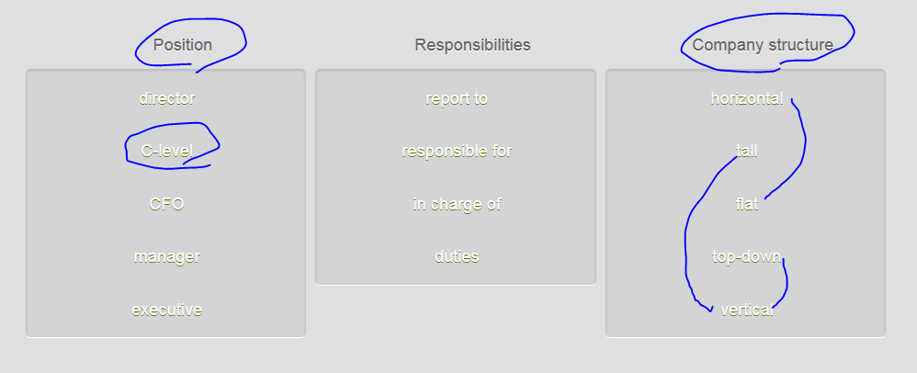

## 表达敬佩

|  |  |  |
| --- | --- | --- |
| 如果你 **admire** 某人，表示你尊敬尊重他。表达敬佩的方法有很多。注意，**respect** 的动词和名词形式相同。 | | |
|  | *I have nothing but* ***respect*** *for the entire team.*  ***I’m very respectful to*** *the entire team* | 我完全是佩服整个团队。 |
|  | *All of the directors* ***respect*** *the decision of the CEO.* | 所有主管都尊敬首席执行官的决定。 |
|  | *We are full of* ***admiration***[ædmə'reɪʃ(ə)n] *for all he has accomplished.* | 我们对他取得的成就满怀敬佩。 |
|  | *I* ***admire*** *her commitment to the company.* | 我赞赏她对那家公司作出的奉献。 |

respectful **/rɪˈspɛktfʊl/**   1.ADJ If you are **respectful**, you show respect for someone. 恭敬的

例：The children in our family **are always respectful to** their elders. 我们家的孩子们总是很尊敬他们的长辈。

* 2.ADV 恭敬地 respectfully "You are an artist," she said respectfully.

“您是一位艺术家，”她毕恭毕敬地说

## 表示敬佩更正式的表达

|  |  |  |
| --- | --- | --- |
| 这些是表示敬佩更正式的表达： | | |
|  |  |  |
|  | *He* ***is held in high esteem*** *[histim连读] by all his colleagues.* | 他深受同事敬重。 |
|  | *I* ***have the greatest regard for*** *everything she has achieved.* | 对她取得的一切成就，我都深感敬佩。 |
|  |  |  |
| 以下表达传达的敬意更深更夸张： | | |
|  |  |  |
|  | *He* ***is in awe of*** *his manager's abilities.* | 他无比敬佩他的经理的才能。 |
|  | *Employees at every level* ***revere*** *the company's founder.* | 公司创始人受到上上下下所有员工的崇敬。 |

e.g.

The CEO is higly **revered** by his employees.  
  
She is held in very high esteem by the CEO.  
  
I have a lot of **admiration** for my manager.  
  
We **have the greatest regard for** the CFO.  
  
He met Bill Gates and was completely in awe of him

Having self-respect/self**-e**steem is very important as well. 拥有**自尊心**同样非常重要。

## Stop Tapescript

You're talking with a friend about business leaders you admire.

Listen and record the correct response. When you see a blank, give true information about yourself.

# Part 4 Developing leaders’ qualities/traits特点；品质, e.g. people skills

一位成功的领导人具有哪些特点 qualities /traits？

* People skills, e.g. empathy = put yourself in others’ shoes
* A strong **sense of ethics, e.g. no pay-cut**
* 我们该如何做好应对突发状况的准备？ Risk management, contingency plan

## Tapescript

**Leader’s qualities and traits:**

|  |  |  |
| --- | --- | --- |
|  | | |
|  |  |  |
|  | | |
|  |  |  |
|  |  |  |

|  |  |  |
| --- | --- | --- |
|  | *Stability is hard to achieve because* ***circumstances change****.* | 环境变了，所以很难实现稳定。 |
|  | *Successful leadership includes* ***persuading others*** *and* ***earning trust****.* | 成功的领导才能包括说服他人和赢得信任。 |
|  | *Good leadership includes both sharing a vision*梦想/憧憬 *and sharing hardshi****p****.* | 优秀的领导能力不仅包括分享梦想/憧憬，也包括共担患难。 |
|  | ***Human nature*** *doesn't change with circumstances.* | 人性不会随着环境改变。（江山易改，本性难移。） |
|  | ***Mental agility*** *will help prepare you for the unexpected.* | 敏捷的思维将有助于你做好应对突发状况的准备。 |
|  |  |  |
| 以下短语可用于谈论货币问题： | | |
|  |  |  |
|  | *Forbes believes that a* ***global currency*** *is important for stability.* | Forbes 认为，全球通用货币对维持稳定非常重要。 |
|  | ***Monetary policy*** *has to do with controlling the supply of money.* | 货币政策与控制货币供应有关。 |

* 思维头脑的敏捷性Mental agility [ə'dʒɪlətɪ]
* 人的自然本性,人性 human nature
* 分享梦想 share a vision (梦想/憧憬)
* 患难与共 share hardship
* 实现你的梦想/憧憬： realize your vision

## Reflexive pronoun

|  |  |  |
| --- | --- | --- |
| 行为发起与行为接受的人或物相同时，使用反身代词reflexive pronoun。在代词后添加后缀 **-self** 或 **-selves** 即可构成反身代词。 | | |
|  |  |  |
|  | *He persuaded* ***himself*** *to trust them.* | 他说服自己信任他们。 |
|  | *The leaders convinced* ***themselves*** *of the need for stronger monetary policy.* | 各国领导人说服自己有必要推行更加强硬的货币政策。 |
|  |  |  |
| **你可以使用反身代词reflexive pronoun加强语气**。注意，在这些例子中，反身代词直接位于代词之前或之后。注：如果去掉反身代词，句子意义并不改变，但失去了强调的语气。 | | |
|  |  |  |
|  | ***She herself*** *brought stability to the company.* | 她**独自一个人/独力** 让公司稳定下来。 |
|  | ***Myself*** *–* ***I*** *don't believe in sharing hardship.* | 我自己 - 我不相信患难与共。 |
|  |  |  |
|  | | |

|  |  |  |
| --- | --- | --- |
| **要强调某事由人单独或没借助他人力量完成，使用反身代词搭配介词 by**。 | | |
|  |  |  |
|  | *Were you able to do it* ***by yourself****?* | 你**自己一个人**能行吗？ |
|  | *She was able to persuade the others* ***by herself****.* | 她**独自一个人**说服了其他人。 |

Tapescript – focus on one point

|  |  |  |
| --- | --- | --- |
| **集中一点** | | |
|  |  |  |
| 如果要强调某事，或是让听众或读者产生期待，集中一点是不错的策略。一种办法是使用类似表达，将听众的注意力集中到话题上： | | |
|  | | |
|  | ***In terms of change****, good leaders know that circumstances change, but* ***human nature*** *does not.* | 就*改变*而言，优秀的领导人懂得环境会变，但人性不会变。 |
|  | ***Concerning*** *corporate hierarchy, there are two basic models.* | 就*公司等级制度*而言，有两种基本的形式。 |
|  | ***With regard to/With respect to*** *leadership characteristics,* ***decisiveness*** *is among the most important.* | 就*领导特质*而言，**果断**是其中最重要的一点。 |
|  | ***Regarding*** *failure, it is not something to be feared.* | 就*失败*而言，它并不可怕。 |

|  |  |  |
| --- | --- | --- |
|  | ***What*** *makes a successful leader is not the same in all circumstances.* | 环境不同，成功领导人的必备素质也不相同。 |
|  | ***How*** *you speak to someone is just as important as what you say.* | 怎么讲和讲什么一样重要。 |
|  |  |  |
| 此外，使用含有 **one** 或 **one of** 的表达也同样有效。 | | |
|  | | |
|  | ***My one lesson I'll give you today*** *is the need for a global currency.* | 我今天要给大家讲授的课程是对于全球通用货币的需求。 |
|  | ***One of the things you should learn*** *is the importance of honesty.* | 诚实的重要性是你应该学习的内容之一。 |

## Summarize “Leader’s qualities/traits/characteristics”

So, **to summarize**, **in terms of** successful leadership characteristics/traits, **one thing** is certain: Some **traits** never change. The need to earn people's trust, share your vision and share hardship, and persuade others does not change.

**With regard to** honesty, it is probably the most important characteristic. And **one other** thing is **mental agility**. The ability to deal with unexpected circumstances is sometimes the difference between success and failure. Oh, yes – and how you deal with people is just as important as what you say to people.

## Reading – **How to developing leadership qualities**

Most human beings **are not born with** leadership skills. But with honesty, hard work and commitment, leadership qualities can be developed.

A first step is to look at your strengths and weaknesses. This is not always an easy task. People can **rarely** do this **entirely** by themselves. **It's likely** you'll need some outside help to evaluate your skills – for example, some feedback from a manager or a colleague.

Once you've identified your strengths, make a plan of action to **maximize** them. If you are good at connecting with an audience and effectively **sharing your vision**, find ways to make an even stronger connection.

More important, recognize your weaknesses and develop a plan to improve those areas.

Some of the things you might work on are communicating effectively; creating enthusiasm for and getting people invested in your vision; treating **associates/colleagues** and their ideas with respect; and taking responsibility for what you say.

All of these things, along with designing a realistic plan to realize your vision, will help you become the most effective leader you can be.

## Writing – how to develop leadership qualities

Write about how to develop leadership qualities. You can write about personal experiences or what you have seen happen in others. What qualities do you think are most important? Do you think everyone has the potential to be a leader? Type in the input box. Write 150-200 words.

**In terms of** leadership, nobody **is born with** leadership charisma, but can develop to be an effective leader based on how much effort they pay to study and learn in the work. Take myself as an example (举一个自己的例子). I was a rookie in project management during the first few years since I jumped into IBM and **clearly** didn't own any leadership qualities, **frankly**. **However**, one time after I successfully monitored, managed, and coped with a critical change during the project life cycle, my manager gave me affirmative **eulogies** and I earned **deluges of** positive feedback from global stakeholders. These praise helped me to enhance my confidence and "**never underestimate myself".** **In retrospect**, I **owe my piece of success to** the following **contributing factors** that drive me to grow as an effective leader step by step.

**The first thing goes to** effective and efficient communication. The best-case is that you can communicate with **associates** at all levels and make sure everyone is standing on the same page. Since I'm working in **a vertical company**, all orders must be **carried out right down**. Whenever I found **conflict of interests**, I try to conduct a smooth communication with my manager firstly. This is be most efficient way of communication.

**Additionally**, I think people skill is another important and necessary factor for me to become a leader, which I still lack of l lot. I should be more **empathetic**, **putting myself into other's shoes**, thinking from other's perspective. I should **share my vision and hardship with colleagues**. Of course, as a leader, **a strong sense of ethics** is also **indispensable (essential)**.

**Last but not least,** I always remind myself to make conclusion based on previous projects and learn lessons. **Retrospective** thinking helps me to **maximize my strengths and recognize weaknesses**, in order to become a more skilled leader.

### Sample

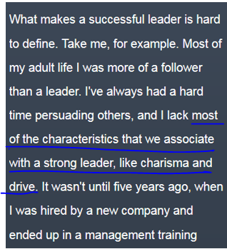 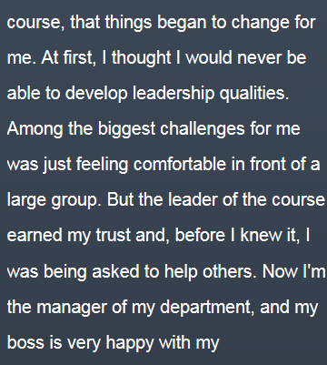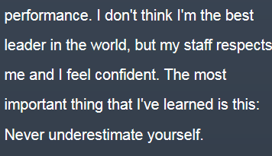

# Writing

**=> Consider SWOT: strength V.S. weakness; Opportunity V.S. threat (like a coin with two side, pros and cons; advantages V.S. downsides)**

# CNN topics